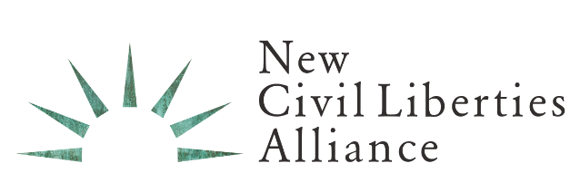

FOR IMMEDIATE RELEASE Media Inquiries: Judy Pino, 202-869-5218

In NCLA Amicus Win, Justice Sotomayor Stays Injunction Against Yeshiva University

YU Pride Alliance, et al. v. Yeshiva University and President Ari Berman

Washington, DC (September 10, 2022) – Justice Sonia Sotomayor has stayed a New York County Supreme Court injunction issued in YU Pride Alliance, et al. v. Yeshiva University and President Ari Berman. The New Civil Liberties Alliance filed an amicus brief in support of Yeshiva University’s Supreme Court application seeking an emergency stay pending appeal of a court order to “immediately” approve an official “Pride Alliance” student club. NCLA argued that the constitutional harms stemming from the injunction were substantial and could continue possibly for years while the case reaches absolute finality. The denial of one’s First Amendment rights, even for short periods, constitutes irreparable harm and necessitates correction by the courts. NCLA commends Justice Sotomayor for halting the injunction and protecting Yeshiva University’s and Yeshiva President Ari Berman’s First Amendment rights.

In this case, the highest state appellate court denied a party’s request for leave to appeal the denial of a stay of such an injunction, and thus, as NCLA argued, the Supreme Court has jurisdiction under its 28 U.S.C. § 1257 precedents, the All Writs Act, 28 U.S.C. § 1651, and 28 U.S.C. § 2101. Because Yeshiva University’s First Amendment claims had been conclusively adjudicated (and improperly rejected) by New York courts, and because a proper resolution of these claims would fully resolve this matter, the Supreme Court has jurisdiction to entertain an application for stay or, in the alternative, a petition for certiorari and should exercise that jurisdiction to prevent irreparable and gratuitous injury to Yeshiva University’s constitutional rights.

If Justice Sotomayor had not acted, Yeshiva University would not be able to teach its vision of Torah values. Outside of the Supreme Court, there was no avenue for interim relief. The New York courts ignored the Supreme Court’s understanding of First Amendment doctrine generally, and its recognition of the importance of “religious education” to observant Jews in particular. In doing so, those courts issued a decision that conflicted with the prior decisions of the Supreme Court. In such circumstances, where First Amendment constitutional harms stem from an injunction, are substantial, and will possibly continue for years, justice must not be delayed.

NCLA released the following statements:

“With injunctions that infringe on a party’s First Amendment rights, the harm they cause is immediate and begins at the time the injunction is ordered. We are pleased the Court issued a stay and Yeshiva University’s constitutional rights have been preserved while this matter is being reviewed.”
— Kara Rollins, Litigation Counsel, NCLA

“As the Supreme Court held almost 80 years ago, ‘if there is any fixed star in our constitutional constellation, it is that no official, high or petty, can prescribe what shall be orthodox in politics, nationalism, religion, or other matters of opinion or force citizens to confess by word or act their faith therein.’ Yet, this is precisely what New York courts are attempting to do. The Supreme Court’s stay order permits Yeshiva University to continue to fulfill its religious mission.”
— Greg Dolin, Senior Litigation Counsel, NCLA

ABOUT NCLA

NCLA is a nonpartisan, nonprofit civil rights group founded by prominent legal scholar Philip Hamburger to protect constitutional freedoms from violations by the Administrative State. NCLA’s public-interest litigation and other pro bono advocacy strive to tame the unlawful power of state and federal agencies and to foster a new civil liberties movement that will help restore Americans’ fundamental rights.
###

